Payeer for CMS DLE 14.3 - Billing 0.7.2

The Billing plugin works correctly on a site with utf-8 encoding, if your site is not configured for this encoding, then you need to install CMS DLE with utf-8.
Download the archive of the Billing plugin from the website dle-billing.com (https://dle-billing.com/module.html) and unzip it.

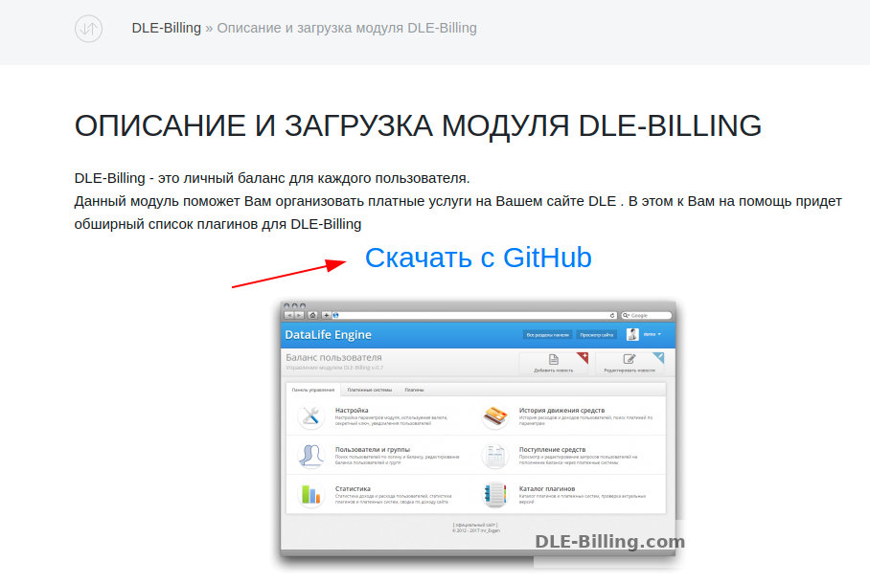
Upload the contents of the "upload" directory from the archive to the root of the site.
Open engine/classes/templates.class.php and find:
$this→_clear();

Add above:
include( ENGINE_DIR . "/modules/billing/helpers/parser.php" );

After that, open the plugin installation page at the link YourSite.com/admin.php? mod=billing
Follow the instructions of the installer.
Download and unpack the archive /EN/payeer-dle-billing.zip
Copy the engine folder via the FTP client to the root of the site.
In the admin panel, go to the section "Other modules –> Баланс пользователя".
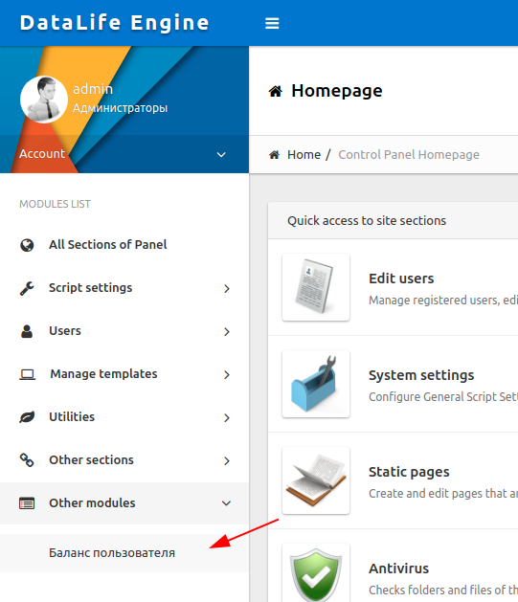

Among the payment systems, find and open the Payeer module.
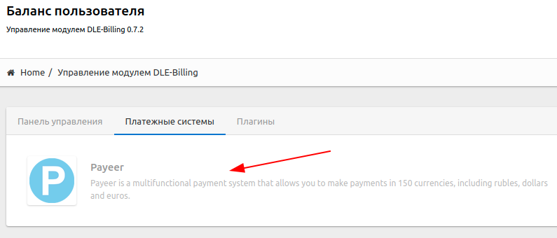

Enable the module, enter the name, the module's currency exchange rate to the standard currency of the site, the minimum and maximum payment amount. The name of the currency should be RUB, USD or EUR.
In the "Integration" section, specify the payment system parameters:
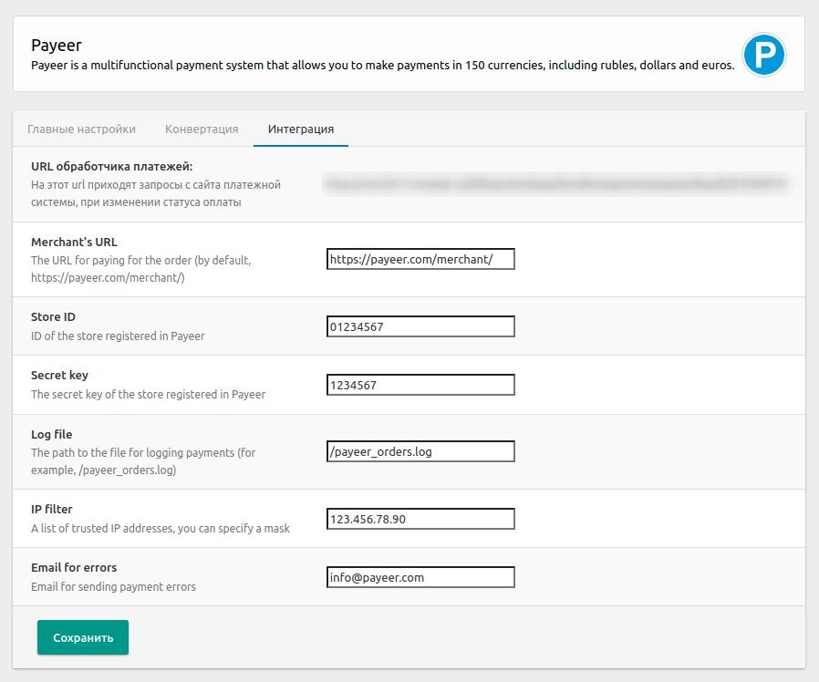

Fill in all the necessary fields:
Merchant’s URL: link to payment system Payeer in (default https://payeer.com/merchant/);
Store ID: ID of your store in the system Payeer (can be found in the personal cabinet);
Secret key: the secret key of your store, you can also find in the personal cabinet;
Log file: the path to the file intended to record the history of payment transactions in the payment system Payeer;
IP filter: IP filter incoming requestsYou can specify the list of all trusted ip addresses of servers, separated by commas. You can also specify a mask instead of the ip address. If the field is empty, checking for trusted ip addresses is not performed.
For example:
192.168.71.87, 192.165.83.17, 192.178.34.15
Or 192.*.71.87, 192.165.83.*, 192.*.34.*
Or *.*.*.* - all available ip addresses;
E-mail for errors: email will be sent notifying you in case of an error of payment. The letter will state the reason and basic information about the payment;

Save the changes.
Specify the URLs in "Payeer account → API → Settings”

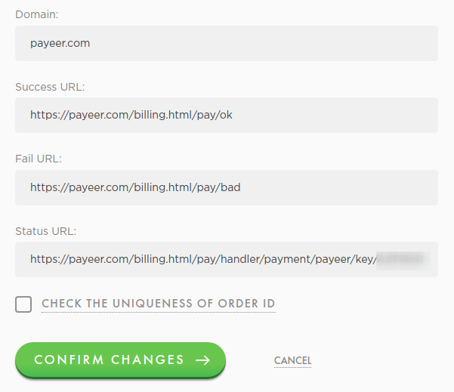

Success URL:
https:// *****/billing.html/pay/ok
Fail URL:
https:// *****/billing.html/pay/bad
Status URL:
#####
Where ***** is your domain, ##### is the URL of the payment notification, available in the Payeer module settings in the "Integration" section.
Confirm changes.
Module Player for CMS DataLife Engine 14.3 - Billing 0.7.2 is configured.

